Sunday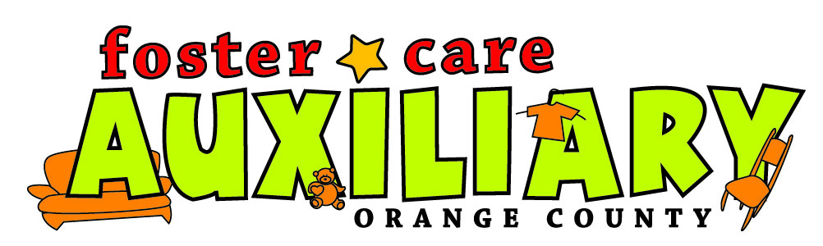Sunday

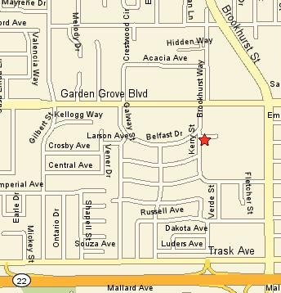
The Foster Care Auxiliary
Invites All Orange County Licensed Foster Families to Attend the Annual
2007 Foster Family Picnic

September 30th 11:00 – 3:00
(lunch served 12 – 2)

Kiwanis Land, 9840 Larson Ave, Garden Grove, CA
(Main Streets; Brookhurst St & Garden Grove Blvd)
Off Garden Grove Blvd. take Kerry to Larson Ave.

Sponsored by Orangewood Children’s Foundation
Children and Family Services & FCAOC

Bugs Bunny & Daffy Duck will be visiting our foster families…provided by Six Flags Magic Mountain

Join the Auxiliary as they put on the 23rd picnic for the foster families of Orange County Social Services. There will be fun, food, rides, entertainment, & prizes. It is our biggest event of the year….you DON’T want to miss it!

Please park only in legal parking spaces at the Boys and Girls Club next door.
************************************************
There will be special prizes for joining the Auxiliary for 2008 at or before the picnic….remember your present membership only lasts through the end of 2007. To join fill out the enclosed membership form or go to our web site, www.FosterCareAux.com to print out a registration form and mail it to FCAOC, Membership Chair, Martin Harvey; 333 S. Brookhurst, Anaheim, CA 92804. You may also join while shopping at the Store on member days or at the picnic! Email FosterCareAux@yahoo.com or call 714 778-3383 for more information on membership or the picnic. We hope to see everyone there!
Membership is NOT required to attend the picnic….all Orange County licensed foster families are invited!

