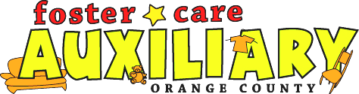

Do You Know Adults or Any Child 16 or Older, who is not in traditional high school,
Who Can’t Read?

Ask them to call

READ/ORANGE COUNTY
714-566-3070

For Free Reading Help by a Trained Volunteer Here in Our Resource Center.

333 S. Brookhurst Street, Anaheim, CA 92804 phone 714-778-3383 www.fostercareaux.com

