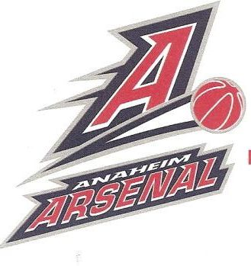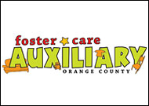

February 2, Anaheim Arsenals BasketBall Game at Anaheim Convention Center 7:30 pm. (playing Idaho) The kids will get to meet the players, participate in on court activities during half time and have a great time. Members will be given a ticket for each one they sell....sell to your neighbors, friends, and relatives and get enough tickets for your whole family to go for free! Everyone is welcome!

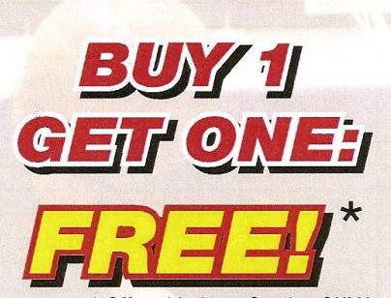
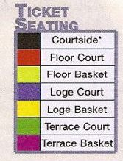
Tickets Available :

Loge Basket $12
(50% of the game is played in front of you)
Loge Court $17
(Less than 20 rows from the court)
Floor Court $20
(2nd best seats in house…right behind the court side seats)

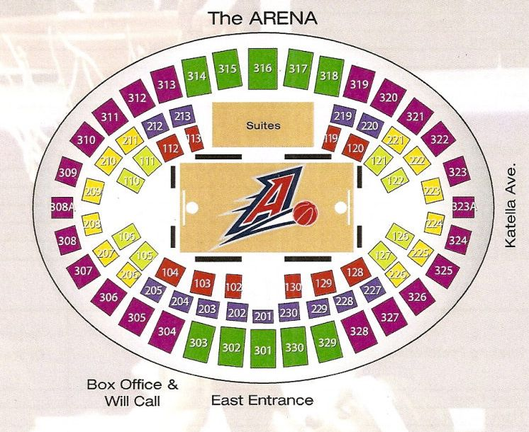
Contact me to arrange ticket delivery when you are finished selling.
Questions? Call Kathy at 714 778-3383 or email FosterCareAux@yahoo.com
Name of ticket purchaser | Phone/email | # of tickets purchased | Price each/and total price | Paid?

