What if Foster Care Auxiliary of Orange County had a penny for every time you searched or shopped the Internet?



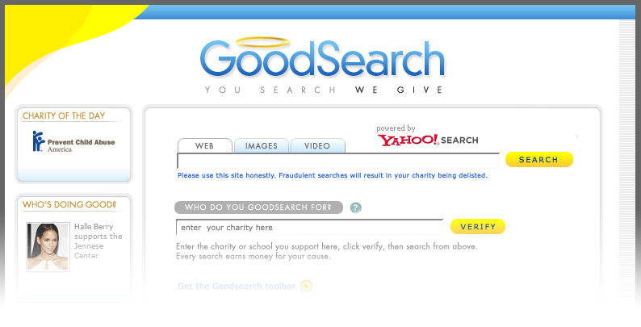
Search or shop the web with www.goodsearch.com and money from Yahoo advertisers will go to Foster Care Auxiliary of Orange County without you spending a dime!

Bring a print out with Foster Care Auxiliary of Orange County in the ‘Who do you goodsearch for’ space and receive a free gift while they last.


