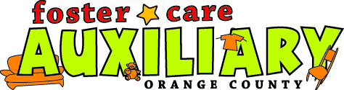

The Foster Care Auxiliary always strives to offer the most possible in ways of providing services, trainings, events, products and services to our foster families.
Presently we offer the following from our resource and distribution center:

Foster Family Friend Program
Reading Literacy Program
Lending Library
Baby Gear Lending Program
Foster Parent Training Opportunities
Fun Family Events
Scholarships
Program to help ageing out foster youth achieve independence
Monthly Distribution Days of new items obtained from community resources
Social Worker referral Family Program for Families in Need with new placements
Thrift Store with deeply discounted used donations
A network of foster families to ask for support and help from
A network of foster families to offer support and help to
And more

If you’d like to receive services from one of the programs, contact us!
If you’d like to volunteer to help serve on one of the programs, contact us!
And if you have ideas on other services and programs for our foster families, contact us!

FosterCareAux@yahoo.com
714 778-3383
333 S. Brookhurst St.
Anaheim, CA 92804
www.FosterCareAux.com

