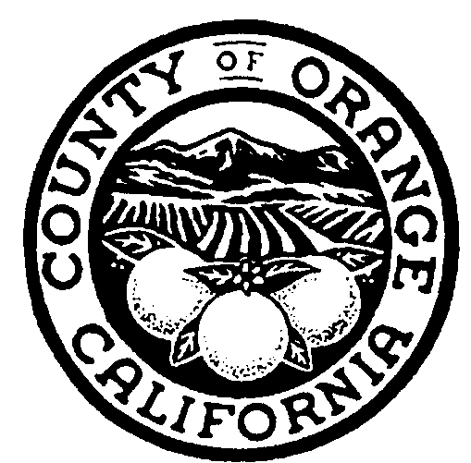
Orange County Children & Family Services
Self Assessment
Feedback Questionnaire

Please identify yourself by checking the appropriate box:
Community Partner Name of Agency _____________________
Parent
Youth
SSA Employee Program/Job Title __________________________
FSS Employee Program/Job Title __________________________
Foster Parent
Relative Caretaker
Court
Other___________________________

Questions
(Please consider the following topics when responding to the questions: available resources, court proceedings, service plan, social worker involvement, supportive services, etc)

1. What practices, programs or interactions with Children & Family Services do you see as strengths?

2. What are areas that need improvement?

3. What suggestions do you have for improvements?

4. Any other comments.

To submit by email to Pam.Paulson@ssa.ocgov.com
By mail: Pam Paulson – Bldg. 128
Children & Family Services
County of Orange/Social Services Agency
P.O. Box 14211, Orange, CA 92868

