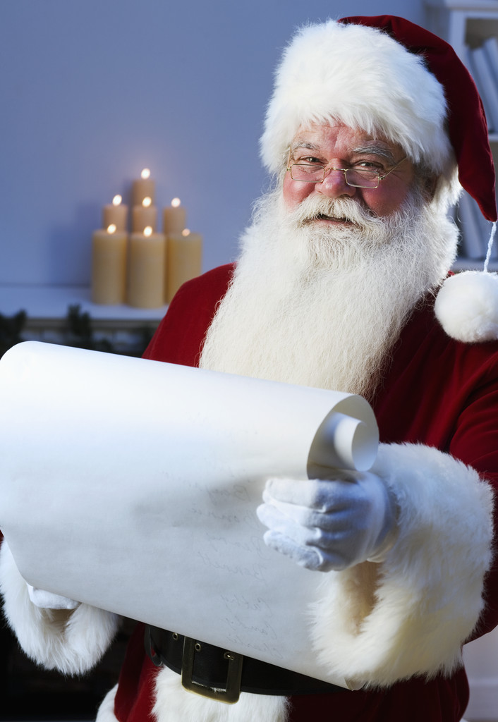

Pictures with Santa and
a store super sale, December 15,
SATURDAY

Come and get a picture taken with Santa…
extras can be obtained for a small fee.
Friends, Family and other visitors can
obtain a picture with Santa for a small
fee also.
Santa will be handing out gifts to
Foster Parent Auxiliary Member Kids.

