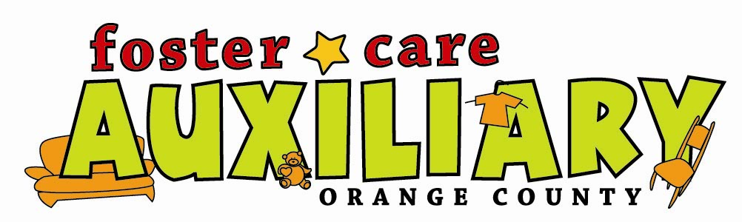
3rd Annual Fundraising Golf Tournament
Friday November 5, 2010
Westridge Golf Club
1400 South La Habra Hills Drive, La Habra 90631 562-690-4200
10:00 check-in,11:30 Shotgun Start Four Man Scramble

Single Player- $150
Includes green fees with cart, use of driving range unlimited balls, and dinner
Foursome- $600
Includes green fees with cart, use of driving range unlimited balls, and dinner
Tee Sponsor- $150
Includes tee sign
Silver Sponsor- $500
Includes golf & dinner for two, your company name on website newsletter, and tee sign
Gold Sponsor- $1,000
Includes golf & dinner for four, your company name on website newsletter, and tee sign
Dinner and Raffle Only- $50

Contact Name____________________Company_____________________
Address______________________________Phone___________________

Please list player names
1.Player_______________________ 2.Player________________________
2.Player_______________________ 3.Player________________________
Dinner Only Names___________________________

Space is limited please submit early
Shirts with a collar and soft spike or spike less shoes only

Please make checks payable to: Foster Care Auxiliary
Non Profit Tax Id # 33-0754615
To sign up, Please mail your entry form and fees to:
Christina Lopez, 329 Diana Pl. Fullerton Ca. 92833 714-396-7212
www.FosterCareAux.com

