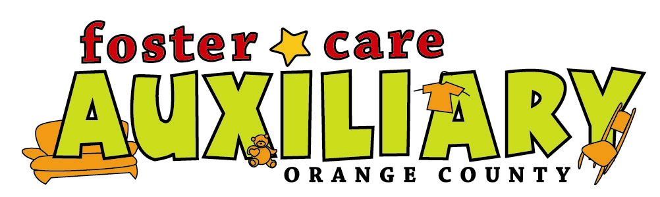

For the year 2011

Check out our programs!
Baby Gear Lending Program, Training Opportunities, Fun Family Events, Scholarships, at least 10 Monthly Distribution Days, Support Group…and more.

*! Members are informed of events, opportunities & meetings through email with our newsletter and via the yahoo group site…make sure you join the site to stay informed. !*

The Auxiliary operates a distribution center filled with community donations for members to select from on the following specific days 10 months each year (not in Sept. or Dec.)
Focus Group Members:
1st Saturday of the month by appointment only. Email fostercareaux@yahoo.com or Call 714 778-3383 with your preferred ½ hour between 9am and 2:00pm.
The Monday and Tuesday after the 1st Saturday will also be Focus Member Distribution Days between the hours of 11am and 1pm. No appointment needed.

Supporting Members
Friday or Saturday following the 1st Saturday of the month from 11-1. No appointment needed

Membership is $75 per calendar year- one membership per household, valid January through December. Volunteering is appreciated from Focus members and required of Supporting members.

To join, please fill out the application below. Make your check payable to “FCAOC”, & mail to
Membership chair: FCAOC-Martin Harvey, 333 S. Brookhurst, Anaheim, CA 92804
For more information call 714 778-3383 or email FosterCareAux@yahoo.com

Foster Care Auxiliary Membership Application 2011
Please print neatly so that we will be able to transfer the information.
Name: ____________________________________________________________
Address: __________________________________________________________
City, state, zip code: _________________________________________________
Email: ___________________________________________________________
Home Phone: ____________________cell: ______________________________
Check all that apply:
Focus Members
- F-1 County of orange licensed foster parents
- F-2 Kinship, NREFM, relative care givers
- F-3 FFA (other agency foster parents, not county of orange) Agency_____________
- F-4 Providers of permanent home for minors from OC foster system(Guardianship, Adoptive)
- F-5 Agency workers collecting distribution for foster children.
Supporting Members:
- S-1 Supporting agency workers– we want to help – let us know your suggestions!
- S-2 Volunteers (A commitment of at least 24 hours during the year is required)
- S-3 Donor – Thanks for your support!

Martin Harvey, membership chair, Email mharvey@socal.rr.com or Phone: 714-778-3383.

Staff Use Only: Payment Method___________ , Attach Receipt and Copy of Check ____ ,
Date Received________, Staff who accepted _____________, Recorded _________

