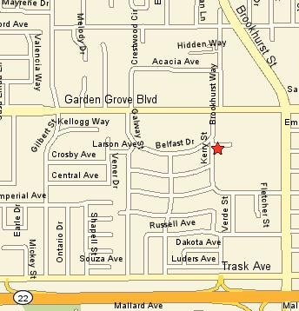
All Orange County Licensed Foster Families Are Invited to Attend the 25th Annual
Foster Family Picnic

Sunday, September 20th, 2009 11:00 – 3:00
(lunch served 12 – 2)

Kiwanis Land, 9840 Larson Ave, Garden Grove, CA
(Main Streets; Brookhurst St & Garden Grove Blvd)
Off Garden Grove Blvd. Take Kerry to Larson Ave.
No Pets are allowed at the Park
Carnival Games DJ Dave! Resources
Prizes Food Entertainment Dance Contest
Bounce Houses Fairy Tale Characters Henna Tattoos

Sponsored by

Orange County Children and Family Services


Questions concerning the picnic should be directed to Maribel Nava or Kathy Harvey FosterCareAux@yahoo.com or 714 778-3383

